Electrical Vestibular System Stimulation vs Sham for Treatment of Posttraumatic Stress Disorder: A Double Blind, Randomized Clinical Trial
Peter J. Colvonen, Ph.D.;^{1,2,3} Christopher Hunt, Ph.D.; ^{1,2} Jane Park, B.S.; ⁴ Kira Clare, B.A.;² Erik Viirre, M.D., Ph.D.;⁵ Shengia Tu, M.S.; ⁶ Xin M. Tu, Ph.D.; ⁶ & Dhakshin Ramanathan, M.D. ^{1,2,3}
Author Affiliations:
¹Department of Psychiatry, University of California San Diego; 9500 Gilman Drive, La Jolla, CA 92037
²VA San Diego Healthcare System, 3350 Villa La Jolla Drive, San Diego, CA 92161
³Center of Excellence for Stress and Mental Health, 3350 La Jolla Village Drive, MC116B, San Diego, CA 92161
⁴Department of Psychology, Arizona State University, 950 S. McAllister Ave, Tempe, AZ 85287
⁵Department of Neurosciences, University of California San Diego; 9500 Gilman Drive, La Jolla, CA 92037
⁶Division of Biostatistics and Bioinformatics, Herbert Wertheim School of Public Health and Human Longevity Science, UC San Diego, 9500 Gilman Dr. La Jolla, CA 92093
Correspondence Peter Colvonen, Ph.D.
San Diego VA Healthcare System, 3350 La Jolla Village Dr. (116B), San Diego, CA 92161
Telephone: 858-552-8585 x2468
Email: PColvonen@Health.UCSD.edu

Abstract
In-home electrical vestibular system stimulation (VSS) represents a promising and underexplored approach to address core physiological dysregulation and arousal symptoms in posttraumatic stress disorder (PTSD). This was a fully remote, double-blind, placebo-controlled, nationally recruited 12-week superiority trial investigating the effects of a non-invasive VSS headset compared to a sham control headset in reducing PTSD symptoms. Participants were > 22 years and < 74 years old, diagnosed with PTSD, and had at least current moderate severity of PTSD (via PTSD Checklist for DSM-5; PCL-5; Mean =51.83; SD=12.91). 383 participants were consented and randomized to active VSS headset or sham (mean age=45.88 years old, SD=10.67 years; 56.70% female). Both groups were advised to use the headset at home for 30 minutes per day for 12-weeks. The headsets are worn like headphones with two self-adhesive electrode pads placed on the skin behind each ear, over the mastoid processes (VSS headset delivers participant-controlled 0.0 - 1.5mA; sham delivers a one-minute ramp up to 1.0mA and back down to 0.0mA to mimic active stimulation). Mixed effects models showed that the VSS group at 12 weeks had a larger decrease in PCL-5 with a 23.5-point decrease (12-week PCL-5 mean=27.3, SD=5.7), while the sham group had a 12.1-point decrease on the PCL-5 (12-week PCL-5 mean=35.7, SD=5.7). There were equal discontinuation rates between groups and minimal unanticipated adverse events reported. Together, 12-week in-home VSS is effective and safe, and shows strong potential as an accessible intervention that may reach a broad population seeking support for PTSD. ClinicalTrials.gov NCT05242367

In the United States, it is estimated that over 80% of the population will be exposed to a traumatic event in their life,^{1,2} with a meta-analysis suggesting a 1-year prevalence of posttraumatic stress disorder (PTSD) ranging from 2.3% to 9.1%, and lifetime prevalence ranging from 3.4% to 26.9%.³ PTSD is associated with substantial morbidity and mortality, high healthcare costs, increased suicidality, depression, general psychiatric distress, worse quality of life, and increased alcohol and drug use.^{4,5} Engagement in and completion of effective treatment for PTSD are critical to both alleviate suffering and reduce the societal and economic impact of trauma. Unfortunately, while there are evidence-based treatments for PTSD (e.g., prolonged exposure [PE]; cognitive processing therapy [CPT]), response rates indicate considerable room for improvement,⁶⁻⁸ and individuals with PTSD face several barriers to mental health care such as distance, travel time and cost, privacy concerns, lack of specialty trained PTSD mental health providers, and perceived stigma of seeking treatment.⁹⁻¹¹
PTSD diagnosis consists of four symptom clusters including intrusions (e.g., nightmares, marked physiological reactivity to reminders), avoidance (e.g., efforts to avoid trauma-related stimuli), negative alterations in cognition/mood (e.g., negative emotional state, detachment, inability to feel positive emotions), and hyperarousal/reactivity (e.g., irritability/angry outbursts, hypervigilance, heightened startle response). While a complex disorder, one major component of PTSD symptomology is hyperarousal,¹² an exaggerated and persistent activation of the body’s stress response system.¹³ Heightened sympathetic nervous system reactivity may lead to symptoms such as hypervigilance, exaggerated startle response, and difficulties with emotion regulation.¹⁴ This, in-turn, can increase avoidance of people and places that may trigger and/or maintain hyperarousal. The vestibular system has been linked to the hyperarousal system.¹⁵
Dysregulation in the vestibular system is linked to heightened autonomic arousal,¹⁵ anxiety,¹⁶ and has been implicated in PTSD.^{17,18} While the exact pathway through which the vestibular system affects the arousal system is not fully understood, it is hypothesized that the through parasympathetic activation,¹⁹ amygdala regulation,²⁰ and cortico-limbic connectivity.²¹ Together, vestibular modulation may support “bottom up” parasympathetic regulation and threat signaling.
A key advantage of the vestibular nerve for treatment is its accessibility for non-invasive stimulation behind the ear, offering a simple and direct path to targeting deep/subcortical limbic brain regions that would otherwise be inaccessible. Delivery of electrical current to the skin over the mastoid region is known to activate all five components of the vestibular apparatus, but lower-level currents (below 3mA) are thought to particularly activate the two otolith organs responsible for detecting linear acceleration and gravity.²² This technique – known as bilateral bipolar galvanic vestibular stimulation – has been used since the 19th century and is long considered safe.²³ Given the vestibular system’s extensive connections with brain regions responsible for anxiety, hyperarousal,¹⁹⁻²¹ electrical vestibular system stimulation (VSS) has potential to regulate arousal systems and in turn, may decrease PTSD symptomology. While previous research suggests that VSS neuromodulation is effective in decreasing insomnia^{24,25} and anxiety,¹⁶ its impact on PTSD has never been examined.
We conducted a fully remote, parallel-group placebo controlled, double-blind, randomized clinical trial examining in-home VSS headset treatment, compared to a sham headset, among participants diagnosed with PTSD. Participants were advised to use the device at home for 30 minutes per day for 12-weeks. We hypothesized that repeated use of the VSS device, compared to sham, would show significant improvement in PTSD severity over time. Secondary outcomes include insomnia severity, quality of life, and generalized anxiety outcomes.
Results
Participant Data
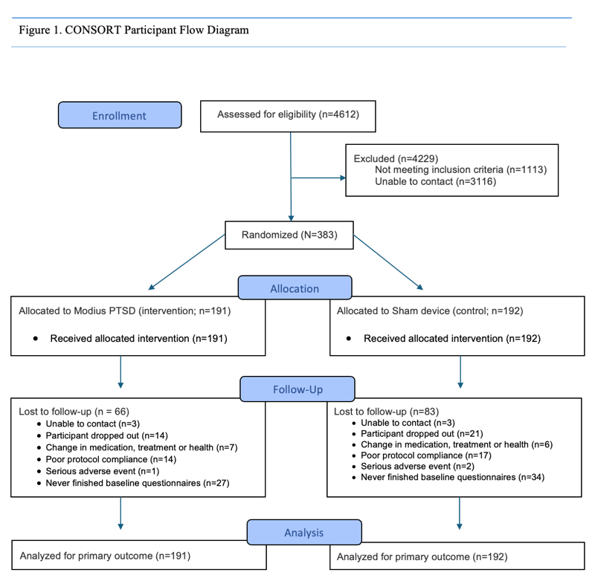
This was a parallel-group, double-blind, sham-controlled, randomized clinical trial comparing 12 weeks of VSS versus sham headsets among individuals with PTSD. This study was approved by the University of California, San Diego Institutional Review Board (#801272), external IRB (Sterling IRB #9739), and was preregistered in February 2022 (ClinicalTrials.gov NCT05242367). Data was collected between February 2023 and December 2024. We recruited nationally in the USA, and all participants provided written informed consent. This study followed the Consolidated Standards of Reporting Trials (CONSORT) reporting guidelines (see Figure 1). The full study protocol is available in the Supplementary Information.

Three hundred and eighty-three adults from around the USA (aged 22-74 years) were consented and randomized (Baseline characteristics for the sample can be found in Table 1). Primary inclusion criteria included: a) Diagnosed PTSD via the Clinician-Administered PTSD Scale for DSM-5 (CAPS-5);²⁶ b) age ≥ 22 years and ≤ 80 years at the time of signing informed consent; c) Ability and willingness to adhere to 30 minute daily device usage for the duration of the trial; d) Stable medication and mental health treatment regimen; e) Access to Wi-Fi. Exclusion Criteria consisted of: a) History of medical conditions that interfere with VSS (e.g., eczema, severe tinnitus, vertigo, history of stroke or severe head injury, presence of malignancy, permanently implanted battery powered medical device or stimulator, diagnosis of epilepsy, pregnant, breast-feeding or intends to become pregnant); b) Taking medications that interfere with VSS (e.g., oral H1 receptor antagonists). The full inclusion and exclusion criteria are presented in supplementary material – Inclusion and exclusion criteria.
While 383 participants were assigned in a 1:1 ratio (191 to the VSS headset and 192 to sham headset), due to international shipping of headsets, we randomized all individuals immediately after consent and before the completion of baseline assessments to ensure the start of treatment could begin immediately after baseline assessments were completed. As such, we had 61 participants randomized who never completed baseline data and never started wearing the headsets (n = 27 VSS; n = 34 Sham). For analyses, while the 61 participants are technically included in our intent to treat (ITT), statistically, they have no data to contribute to the modeling. We have taken the conservative approach and noted this group as “excluded from analysis” (see Figure 1. Consort flow diagram).
Main analyses
Changes in PCL-5, ISI, SF-36 emotional health, and GAD-7 were best modeled with a random intercept and slope and a logarithmic effect of time, whereas SF-36 physical health was best modeled with these same parameters plus an intercept-slope correlation. Detailed results of model fitting procedures can be found in Table 1S of the Supplement 1. Results from best fitting models can be found in Table 2S of Supplement 1.
Primary outcome: PTSD (see Table 2 for Means and 95% confidence intervals at each timepoint and figure 2). For PCL-5, there was a significant effect of time, b = -12.7, 95% CI = -15.03, -10.59, p < .001, d = 1.3, and a significant effect of Time x Treatment Group interaction b = -4.34, 95% CI = 7.18, -1.03, p = .007, d = 0.32. Thus, PCL-5 scores decreased significantly in both groups across time, with the VSS group having exhibited an even larger decrease in PCL-5 scores at week 12 relative to the sham group. The main effect of group was also significant, b =
Figure 2. Posttraumatic Stress Disorder Symptom Severity Estimated Means by Treatment Condition at Each Time Point, with Standard Deviations

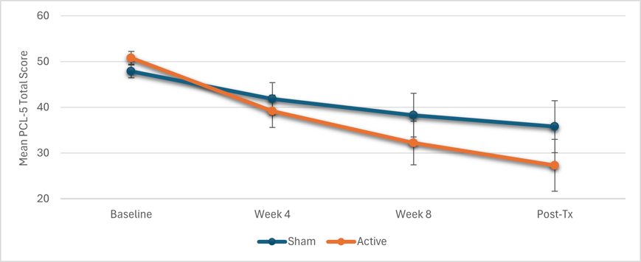
2.96, 95% CI = 0.17, 5.75, p = .037, d = 0.32, indicating slightly higher PCL-5 scores in the VSS relative to the sham group at baseline. The VSS group showed a 23.5 point decrease at week 12, while the sham group showed a 12.1-point decrease. As such, while both groups decreased in PTSD symptoms over time, the VSS group had an 11.4 point larger drop in PCL-5 scores at week 12 compared to sham.
Secondary outcomes: sleep, quality of life, and anxiety (see Table 2 for Means and 95% confidence intervals at each timepoint and figure 3). Models for secondary outcomes (ISI, SF-36 physical health, SF-36 emotional health, GAD-7) revealed a significant effect of time for ISI, b = -3.37, 95% CI = -4.22, -2.52, p < .001, d = 0.62, the SF-36 emotional health component, b = 7.67, 95% CI = 4.54, 10.80, p < .001, d = 0.38, and GAD-7, b = -3.1, 95% CI = -3.82, -2.38, p < .001, d = 0.67, but not the SF-36 physical health component (p = .502). Thus, participants in all groups showed significant improvements in insomnia, anxiety, and general emotional health over the course of treatment, whereas physical health did not improve. Critically, the Group x Time interaction was significant for each secondary outcome, including ISI (b = -2.12, 95% CI = -3.29, -0.95, p < .001, d = 0.28), the SF-36 physical component (b = 6.43 95% CI = 2.63, 10.25, p = .001, d = 0.26), the SF-36 emotional component (b = 7.53, 95% CI = 3.21, 11.86, p < .001, d = 0.36), and GAD-7 (b = -1.27, 95% CI = -2.26, -0.27, p < .01, d = 0.2). The VSS group showed a 7.6-point reduction, on average, in the ISI over time and had a 5.9 point greater improvement in
Figure 3. Secondary Treatment Outcome Means by Treatment Condition at Each Time Point, with Standard Deviations
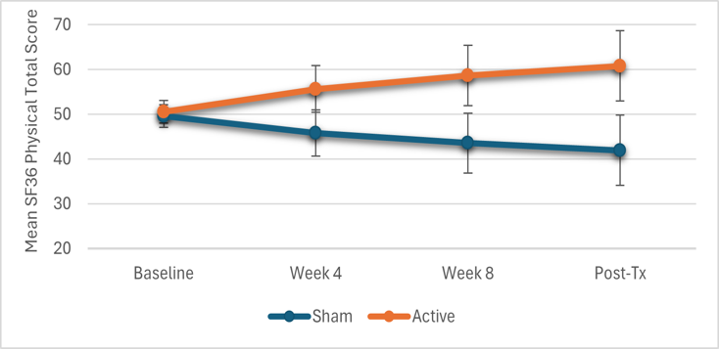 | 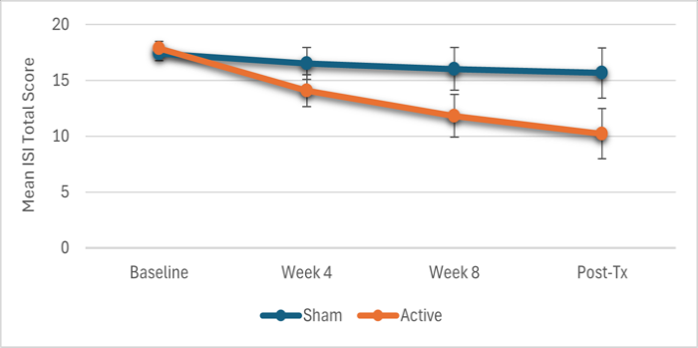
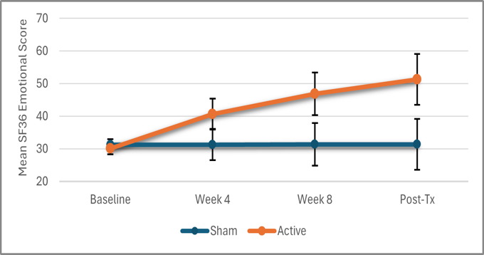 | 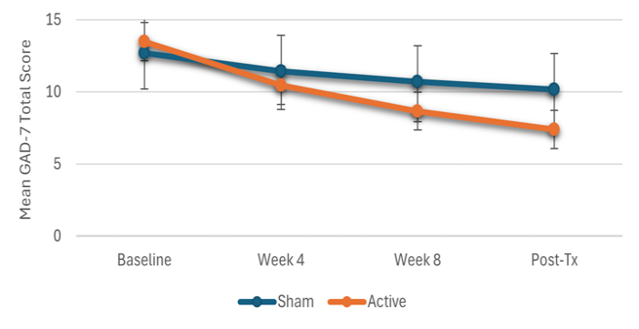

the ISI relative to the sham group with at week 12. Overall, participants randomized to the VSS device showed greater improvements in insomnia, general emotional health, general physical health, and anxiety over the course of treatment relative to participants randomized to the sham group. The main effect of group was not significant for any secondary outcomes (ps > .125), indicating equal levels of the outcome between groups at baseline.
Blinding: Blinding was evaluated using James’ Blinding Index (JBI),²⁷ which quantifies the degree of participant uncertainty regarding treatment assignment. Based on JBI, “don’t know” responses as full blinding (weight = 1.0) and both correct and incorrect guesses as partial blinding (weight = 0.5). JBI yields values from 0 (complete unblinding) to 1 (maximal uncertainty), with 0.50 indicating ideal blinding consistent with random guessing. Among participants, 49.2% correctly recorded their assignment, 22.7% recorded incorrectly, and 28.1% reported that they did not know their assignment. The resulting JBI score was 0.64, suggesting adequate blinding with individuals in the VSS condition having a higher chance of correctly reporting their group compared to sham.
Adverse Events (AE)/Serious Adverse Events (SAE):
Anticipated AEs are reported for week 12 (see Table 3). There were no differences between VSS and sham headsets on any of the adverse event categories (e.g., tingling behind the ears, mild headache). The largest percentage of AE was dizziness in the VSS headset group with 12.4% compared to 5.3% in the sham headset group.
All unanticipated AE/SAEs were followed up with by the principal investigator and medical professionals as needed. There were 13 mild AEs and 11 SAEs reported. Of the 13 mild AEs, three were likely related to the device and include: headaches and nausea when using the device (sham condition; withdrawn), a hypnopompic event (sham condition; withdrawn), a rash on neck (sham condition; 5-day break and sent hypoallergenic pads and continued). Of the 11 SAEs, none were related to the device: grand mal seizure who had a history of hypertension (sham condition; withdrawn); medication overdose (VSS condition; withdrawn); breast cancer diagnosis (sham condition; continued); kidney infection (VSS; withdrawn); motor vehicle collision death (VSS condition; withdrawn); suicide attempt (sham; withdrawn); hospital bacterial infection (sham; continued); hospitalized with pneumonia (sham; continued); infected cut on ankle, sepsis (VSS condition; continued); broken ankle (VSS condition; withdrawn); subconjunctival hemorrhage (sham condition; continued). All participants were included in analyses.
Discussion
Our study was the first RCT examining VSS for PTSD with a double-blind, randomized clinical trial comparing 30 min/day of in-home VSS for 12 weeks to a sham stimulation control among 383 participants with PTSD. We found the VSS group showed significantly larger decreases in PTSD at 12-weeks compared to sham control with a medium effect size. The vestibular system, which plays a key role in arousal modulation and autonomic regulation, offers a novel target for PTSD symptom reduction. Easy access to headsets for in-home use can reach a large population of individuals seeking support for PTSD symptomology. Together, VSS is a promising and underexplored approach to address core physiological arousal dysregulation present in PTSD.
The VSS group showed significantly larger decreases in PTSD at 12-weeks compared to sham control. The VSS group showed a 23.5 point drop at post-treatment week 12, while the sham group had a 12.1-point decrease. The sham group did show a 12.1-point decrease in PTSD which may reflect nonspecific therapeutic factors such as expectancy/placebo effects, regression to the mean, increased self-monitoring during the trial, and the supportive structure and attention inherent to participation in a clinical study. The larger decrease in the VSS group is clinically meaningful and tends to be on the higher end of trauma-focused therapy outcomes.²⁸⁻³⁰ Further, while both groups decreased in PTSD symptoms over time, the VSS group had an 11.4 point larger drop in PCL-5 scores at week 12 with a small effect sizes above the sham group at post-treatment, representing a statistically and clinically meaningful difference.³¹ ³² Considering the safety profile of VSS, VSS makes a practical and effective tool for treating PTSD symptomology that is worthy of further exploration.
There are other evidence-supported neuromodulation treatments for PTSD, with the most research and implementation being repetitive transcranial magnetic stimulation (TMS), which also shows small to modest effects on PTSD.³³⁻³⁵ Similar to repetitive TMS, VSS may not replace evidence-based trauma-focused psychotherapy in terms of evidence strength for PTSD and does not address the trauma memory directly.³⁶ However, VSS has initial evidence to be effective in decreasing PTSD symptoms with a strong safety profile, making it a useful tool for patients who are treatment-resistant, intolerant of existing interventions, have significant comorbidity (e.g., depression), have stigma to PTSD treatment, or have trouble getting treatment from a trained PTSD clinician. VSS has the potential to expand access for patients facing long wait-lists (e.g., VA healthcare systems), geographic barriers (e.g. rural), or limited means to highly trained PTSD clinicians. Finally, because daily usage data are tracked, devices could be monitored remotely, facilitating measurement-based care within large systems like the VA or hospital systems and reducing clinician touch-time per patient. Together, VSS may fill these gaps in neurostimulation treatment and PTSD treatment as a pragmatic first-line treatment for PTSD symptoms or a step-care bridge that is easier to access in-home.
While the pathways that VSS directly affects PTSD symptoms are still being examined,¹⁵⁻¹⁷ we hypothesize that decreasing daytime hyperarousal directly affects other symptomatic improvement. Decreasing hyperarousal can reduce behavioral avoidance and hypervigilance³⁷ and also erode overgeneralized negative beliefs about the world being dangerous.³⁸ While decreasing hyperarousal cannot directly address every PTSD symptom, it may start a cascade of positive changes that may ameliorate non-arousal-related symptoms as well. For instance, decreasing hyperarousal to trauma-related situations may decrease avoidance and increase engagement in daily activities,³⁹ which, in turn, may help reduce depressive-like PTSD symptoms like anhedonia and persistent negative affect.⁴⁰ Similarly, patients who are less physiologically aroused when recalling trauma memories can direct more attention toward processing those memories, which can reduce inaccurate appraisals about the causes of the trauma (e.g., blaming oneself for the trauma) and negative emotions that depend upon those faulty appraisals (e.g., shame, guilt).⁴¹
Our secondary analyses showed the VSS not only had significant 7.6 point decrease in ISI scores at week 12, but also showed a 5.9 point larger decrease than the sham device in insomnia severity. It may be possible that decreases in PTSD led to decreases in insomnia. However, previous PTSD studies showed that insomnia often does not fully remit following evidence-based treatments,⁴² as insomnia is a fully independent disorder that is not adequately addressed by trauma-focused PTSD interventions.⁴² It could be that decreases in insomnia lead to decreases in PTSD; this is also not supported in the literature.⁴³ More convincingly, PTSD and insomnia have a shared mechanistic overlap with autonomic regulation and arousal systems^{44,45} that are both targeted by vestibular system activation.^{17,24} Taken together, VSS likely affects the overlapping arousal systems of PTSD and insomnia and uniquely addresses both disorders. Given the novelty of our findings, future studies should confirm our findings and examine directional pathways for VSS treatment outcomes between PTSD and insomnia.
Secondary analyses also found that VSS showed larger increases than the sham group in both physical and emotional health quality of life scores and larger decreases in generalized anxiety disorder severity. This is unsurprising given the findings that VSS positively affected both PTSD and insomnia severity. It is possible that the decreases in hyperarousal symptoms of PTSD and insomnia severity leads to increases in “moderate/vigorous” physical activity and increases in emotional health associated with higher quality of life and lower anxiety.
Limitations. Although our present study represents the most comprehensive investigation of VSS on PTSD, it does possess several limitations. First, we use self-report measures as our primary outcomes. While we administered the CAPS for at baseline to ensure PTSD diagnosis, using the CAPS as an outcome measure for PTSD at post-treatment and follow-ups would increase objective outcomes in future studies. Second, we randomized participants before completing baseline data to minimize the wait time to receive internationally delivered headsets following baseline completion. While this did allow participants to start treatment immediately following baseline to maximize treatment readiness, 61 participants never responded to outreach and never completed baseline questionnaires. Third, we have adequate, but not perfect, blinding as indicated by the JBI such that participants in the active condition were more likely to guess they were in the correct treatment. Fourth, we increased our recruitment N mid study to allow for secondary analyses. To minimize any concerns with attempting to manipulate the p-value, we record all means and effects sizes, which are not influenced by sample size. Fifth, there is no way to ensure the specificity of VSS stimulation and knowing which brain regions are engaged. Finally, we do not perform a follow-up assessment to address treatment durability.
Strengths. Our study has several major strengths adding to our findings. First, we used an active control sham headset that showed significant decreases in our primary outcome (12.1 point drop on the PCL-5 at 12-week post-tx assessment). This is a larger control condition effect than most randomized trauma-treatment trials. For example, Thorp et al.²⁸ found their supportive therapy control group had a 2.03 point drop on the PCL-S, and a recent examination of CPT showed their control waitlist had a 2.62 point increase in PCL-5 scores.⁴⁶ Second, we had a large sample size, national representation, and diverse gender and ethnicity demographics. This maximizes our generalizability of VSS effects to a wide population.
Conclusions: This trial is the first to demonstrate that non-invasive VSS meaningfully reduces PTSD symptoms as well as related sleep and quality of life impairments in a large, national sample. Given its favorable safety profile, ease of home use, and effectiveness for PTSD symptoms, VSS represents a promising addition to the PTSD treatment toolbox. Rigorous confirmational, mechanistic, long-term, and real-world effectiveness studies are now warranted to define its role in integrated, stepped-care models for trauma-related disorders.
Methods
Ethics and Study Design
This was a parallel-group, double-blind, sham-controlled, randomized clinical trial. This study was approved by the University of California, San Diego Institutional Review Board (#801272), external IRB (SterlingIRB #9739), and was preregistered in February 2022 (ClinicalTrials.gov NCT05242367). Data was collected between February 2023 and December 2024. We recruited nationally in the USA, and all participants provided written informed consent. This study followed the Consolidated Standards of Reporting Trials (CONSORT) reporting guidelines (see Figure 1). The full study protocol is available in the Supplementary Information.
Participants
Three hundred and eighty-three adults from around the USA (aged 22-74 years) were consented and randomized (see Figure 1; Baseline characteristics for the sample can be found in Table 1). Primary inclusion criteria included: a) Diagnosed PTSD via the Clinician-Administered PTSD Scale for DSM-5 (CAPS-5);²⁶ b) age ≥ 22 years and ≤ 80 years at the time of signing informed consent; c) Ability and willingness to adhere to 30 minute daily device usage for the duration of the trial; d) Stable medication and mental health treatment regimen; e) Access to Wi-Fi. Exclusion Criteria: a) History of medical conditions that interfere with VSS (e.g., eczema, severe tinnitus, vertigo, history of stroke or severe head injury, presence of malignancy, permanently implanted battery powered medical device or stimulator, diagnosis of epilepsy, pregnant, breast-feeding or intends to become pregnant); b) Taking medications that interfere with VSS (e.g., oral H1 receptor antagonists). The full inclusion and exclusion criteria are presented in supplementary material – Inclusion and exclusion criteria.
Procedures
Participants were recruited through a contracted clinical trial management company (CT Mentors; Dublin, Ireland), which remotely coordinated recruitment with social media posts. Individuals filled out a self-assessment online pre-screening form, followed by a telephone call with a contracted research organization member to complete full screening. Individuals provided written informed consent and met with a study member to conduct the CAPS-5. Individuals meeting PTSD criteria were randomized and sent a headset from Belfast, Ireland. Baseline assessments were conducted within 7 days of randomization. All study staff completed training in clinical trials ethics and good clinical practice. Assessors were trained in administering CAPS-5 and other assessments. Participants were compensated $20 for each of four visits (Baseline, week 4, week 8, week 12). Participants were asked to send headsets back in a pre-paid package and received another $20 when they return the headset for a total possible $100.
Randomization
383 participants were assigned in a 1:1 ratio (191 to the VSS headset and 192 to sham headset). Due to international shipping of headsets, we randomized all individuals immediately after consent but before the completion of all baseline assessments to ensure the start of treatment could begin as soon as baseline assessments were completed. As such, we had 61 participants randomized who never completed baseline data and never started wearing the headsets (n = 27 VSS; n = 34 Sham; see Results section for attrition analyses). For analyses, while the 61 participants are technically included in our con, statistically, they have no data to contribute the modeling. We have taken the conservative approach and noted this group as “excluded from analysis” (see Figure 1. Consort flow diagram).
Intervention
VSS and sham headsets were administered using the Modius PTSD device (Neurovalens, Belfast, Ireland) with headsets appearing identical externally and can only be distinguished by a unique serial number. The headset is worn on the head in a manner analogous to headphones and uses two self-adhesive electrode pads which are placed on the skin behind each ear, over the mastoid processes. All participants received the same training for use, controls of headset, directions to sit or lay down while using, and safety (e.g., not to use while driving). All participants were asked to wear the headset approximately 1 hour before bed for 30 minutes a day for 12 weeks. Both the active and sham devices apply the stimulus as a biphasic pulse train with alternating polarity. All participants, assessors, and the clinical trial team were blinded to device allocations to maintain double blinding. Following treatment, participants were asked to indicate which intervention they believed they received.
VSS Device (0.0 - 1.5mA; frequency of 0.25Hz). When initially switched on, the default level of stimulation is 0mA (Level 0). The user then increases the stimulation in 0.1mA increments until the desired level is reached with a total of 15 levels (1.5mA max). The device automatically stopped after 30 minutes.
Sham Device (1.0mA; frequency of 0.8Hz for 30 seconds): The sham devices applied a non-clinical stimulation to the user for 30 seconds, before tapering down to zero over a further 30 seconds, thus creating the impression of an active device.
Measures
Primary Outcomes
PTSD: PTSD was assessed using the PTSD checklist for DSM-5 (PCL-5).⁴⁷ The PCL-5 consists of 20 items, which assess how much they are bothered by PTSD symptoms over the past month on a scale from 0 (not at all) to 4 (extremely). Total scores range from 0 to 80 with higher scores indicating higher PTSD severity. The PCL-5 had good internal consistency (α = .82).
Secondary Outcomes
Insomnia: Insomnia Severity Index (ISI)⁴⁸ was used to measure insomnia. The ISI consists of seven items: three items assess severity of insomnia (i.e., degree of difficulty falling asleep, staying asleep, and waking too early) and four items address satisfaction with sleep, effect of sleep on daytime and social functioning, and concern about current sleep difficulties. Scores range from 0 (no insomnia) to 28 (severe insomnia). ISI showed strong internal consistency (α = .81).
Quality of Life: Health-related quality of life was assessed using the 36-Item Short Form Survey (SF-36)⁴⁹ self-report instrument that evaluates 8 scales of functioning. We used the commonly utilized two global domains of functional health and well-being: a physical health component summary and an emotional health component summary.⁵⁰
Anxiety: Anxiety was measured using the Generalized Anxiety Disorder 7-Item Scale (GAD-7) ),⁵¹ a self-report questionnaire that assesses 7 core anxiety symptoms (i.e., excessive or uncontrollable worrying, restlessness, and irritability) over the prior 2-week period on a scale from 0 (not at all) to 3 (nearly every day). Total scores range from 0 (no anxiety) to 21 (severe anxiety). The GAD-7 displayed reliable internal consistency (α = .92).
Adverse Events/Serious Adverse Events: AE/SAEs were defined in accordance with the European Standard BS ES ISO 14155:2020. AE: Any event (device related or not), untoward medical occurrence, unintended disease or injury, or untoward clinical signs in participants, users or other persons. For participants, this definition relates to all study procedures and comparators; for users and other persons, it relates only to the investigational medical device. SAE: Any event (device related or not) that led to death, led to serious deterioration in the health of the participant, that either resulted in a life-threatening illness or injury, or a permanent impairment of a body structure or a body function, or in-patient or prolonged hospitalization, or medical or surgical intervention.
Data Analysis
The power calculation was informed by a trial conducted by Zalta et al., using the PCL-5 score.⁵² There is limited literature available for power analyses, and many of the previous VSS studies used 4 week treatments. We extended our use time 12 weeks to mimic PE and CPT trials (8-12 weeks). Therefore, a mean difference between groups of 14 (using original SD of 17.3) gives 33 per group. A 20% dropout would give 41 per group. Therefore, we proposed a sample size of n = 100 (50 per group). The power calculation was generated using G*Power Statistical Analysis software (ver. 3.1.9.4). Mid-study, we increased the sample to 383 randomized to account for the no-baseline data group, to maximize safety data and AE information, increase generalizability, and to allow future secondary analyses. To limit any concerns with attempting to influence the p-value with sample size, we present means and effect sizes for all analyses, which are not influenced by sample size. The blind was not broken prior to the completion of the study.
Mixed effects models⁵³ were used to analyze group differences in PCL-5, ISI, GAD-7, and the physical health and emotional health components of the SF-36 over time using SPSS version 28.⁵⁴ These models allow data from randomized participants to yield consistent estimates under the missing at random assumption.⁵³ We tested different combinations of random effects (intercept, slope, and intercept-slope covariation) and definitions of time (linear and logarithmic) and retained the best-fitting/most parsimonious combination for each outcome. Within the best-fitting model for each outcome, we tested treatment condition, time, and their interaction as fixed effects. Time was coded as 0 (baseline), 1 (week 4), 2 (week 8), and 3 (week 12 post-treatment), while group was coded as 0 (sham) and 1 (VSS). Week 12 is the primary endpoint for all analyses. For a measure of effect size, we computed a d value for each effect according to the formula d = t(2/n)^{1/2}, which can be applied to any test that yields a t statistic.⁵⁵ Full model outputs are in the Supplement 1.

Author Contributions: PC designed the study and procured the research funding. PC, CH, JP, KC contributed to data collection. Statistical Analyses were developed and run by CH, ST, XT. PC, EV, CH, JP, ST, XT, DR accessed and verified the underlying data. All authors contributed to the writing of the article. All authors had full access to all the data in the study and had the final responsibility for the decision to submit the manuscript for publication.
Data Sharing: See Supplement 1
Funding/Support: This was an investigator-initiated study sponsored and funded by Neurovalens.
Role of the Funder/Sponsor: Neurovalens had a role in the design of the study. Neurovalens approved the plan for, but did not participate in, the collection, management, analysis of the data, or decision to publish. The company had no approval authority for the manuscript prior to submission, including no right to veto publication and no control on the decision regarding to which journal the manuscript was submitted.
Trial Registration: ClinicalTrials.gov Identifier: NCT05242367, February 2022 (https://clinicaltrials.gov/study/NCT05242367)
Acknowledgments: The contents do not represent the views of the U.S. Department of Veterans Affairs or the United States Government or Neurovalens.
Keywords: PTSD, Vestibular Nerve Stimulation, Neuromodulation
Conflicts of Interest: None of the authors have conflicts of interest.

Table 1. Demographics and Baseline Characteristics of Study Participants
Characteristics | Total  (N = 322) |  |  |  | VSS  (n = 164) |  |  |  |  | Sham  (n = 158)
Age, mean (SD) | 45.9 | (10.8) |  |  | 45.7 |  | (10.3) |  |  | 46.1 |  |  | (11.3)
Sex, n, %
Male | 166 | 43.3% |  |  | 84 |  | 44.0% |  |  | 82 |  |  | 42.7%
Female | 217 | 56.7% |  |  | 107 |  | 56.0% |  |  | 110 |  |  | 57.3%
Years of Education, mean (SD) | 15.4 | (2.7) |  |  | 15.4 |  | (2.9) |  |  | 15.3 |  |  | (2.5)
Ethnicity, n, %
Hispanic | 41 | 13.4% |  |  | 19 |  | 12.3% |  |  | 22 |  |  | 14.6%
Non-Hispanic | 264 | 86.6% |  |  | 135 |  | 87.7% |  |  | 129 |  |  | 85.4%
Race, n, %
White | 251 | 82.3% |  |  | 128 |  | 83.1% |  |  | 123 |  |  | 81.5%
Black | 13 | 4.3% |  |  | 7 |  | 4.5% |  |  | 6 |  |  | 4.0%
Asian | 6 | 2.0% |  |  | 3 |  | 1.9% |  |  | 3 |  |  | 2.0%
American Indian/Alaska  Native | 4 | 1.3% |  |  | 1 |  | .6% |  |  | 3 |  |  | 2.0%
Multi-racial | 21 | 6.9% |  |  | 11 |  | 7.1% |  |  | 10 |  |  | 6.6%
Other | 10 | 3.3% |  |  | 4 |  | 2.6% |  |  | 6 |  |  | 4.0%
Job Status, n, %
Employed Full-time | 103 | 31.5% |  |  | 56 |  | 33.9% |  |  | 47 |  |  | 29.0%
Employed Part-time | 30 | 9.2% |  |  | 18 |  | 10.9% |  |  | 12 |  |  | 7.4%
Self-employed | 37 | 11.3% |  |  | 15 |  | 9.1% |  |  | 22 |  |  | 13.6%
Retired | 50 | 15.3% |  |  | 20 |  | 12.1% |  |  | 30 |  |  | 18.5%
Student | 8 | 2.4% |  |  | 3 |  | 1.8% |  |  | 5 |  |  | 3.1%
Unemployed | 99 | 30.3% |  |  | 53 |  | 32.1% |  |  | 46 |  |  | 28.4%
Baseline assessment scores, mean (SD)
PTSD severity (PCL-5) | 51.8 | (13.1) |  |  | 53.2 |  | (13.1) |  |  |  | 50.2 |  | (12.9)
Insomnia severity (ISI) | 18.1 | (5.8) |  |  | 18.3 |  | (6.1) |  |  | 17.9 |  |  | (5.6)
Physical health (SF-36) | 33.4 | (39.8) |  |  | 34.6 |  | (40.4) |  |  | 32.1 |  |  | (39.3)
Emotional health (SF-36) | 37.7 | (17.1) |  |  | 37.2 |  | (17.7) |  |  | 38.4 |  |  | (16.5)
Anxiety (GAD-7) | 13.7 | (4.7) |  |  | 14.1 |  | (4.8) |  |  | 13.3 |  |  | (4.5)
Takes Medications, n (%) | 197 | 68.6% |  |  | 102 |  | 70% |  |  | 95 |  |  | 67%
Average Num. of Medications | 2.5 | (2.5) |  |  | 2.4 |  | (2.4) |  |  | 2.5 |  |  | (2.7)
Average Days of Device Use a Week | 6.3 | (2.8) |  |  | 6.1 |  | (2.7) |  |  | 6.5 |  |  | (3.0)
Average Years Since Trauma | 21.69 | (16.1) |  |  | 23.7 |  | (16.4) |  |  | 19.7 |  |  | (15.6)
Note: Abbreviations: SD = standard deviation; PCL-5 = PTSD checklist for DSM-5; ISI = insomnia severity index; GAD-7 = Generalized Anxiety Disorder.

Table 2. Estimated means and 95% confidence intervals at each timepoint
Measure | Mean (95% CI)  Baseline | Week 4 | Week 8 | Week 12/Post Tx
Primary

PCL-5
VSS | 50.8 (49.4 – 52.2) | 39.1 (35.6 – 42.6) | 32.2 (27.4 – 37.0) | 27.3 (21.6 – 32.9)
Sham | 47.8 (46.4 – 49.2) | 41.8 (38.3 – 45.3) | 38.3 (33.5 – 43.0) | 35.7 (30.0 – 41.4)
Secondary
ISI
VSS | 17.9 (17.2 – 18.5) | 14.1 (12.7 – 15.5) | 11.8 (9.9 – 13.7) | 10.2 (8.0 – 12.5)
Sham | 17.4 (16.8 – 18.0) | 16.5 (15.1 – 18.0) | 16.0 (14.1 – 17.9) | 15.7 (13.4 – 17.9)
SF-36 Emotional
VSS | 30.1 (28.4 – 31.9) | 40.6 (35.9 – 45.4) | 46.9 (40.3 – 53.4) | 51.3 (43.5 – 59.1)
Sham | 31.2 (29.4 – 33.0) | 31.3 (26.5 – 36.1) | 31.4 (24.8 – 37.9) | 31.4 (23.6 – 39.2)
SF-36 Physical
VSS | 50.5 (48.0 – 53.1) | 55.6 (50.5 – 60.8) | 58.7 (51.9 – 65.4) | 60.8 (53.0 – 68.6)
Sham | 49.6 (47.0 – 52.1) | 45.8 (40.6 – 51.0) | 43.5 (36.8 – 50.3) | 41.9 (34.1 – 49.8)
GAD-7
VSS | 13.5 (13.2 – 16.0) | 10.5 (9.5 – 13.6) | 8.7 (7.3 – 12.3) | 7.4 (5.7 – 11.3)
Sham | 12.7 (10.2 – 13.0) | 11.4 (8.3 – 12.4) | 10.7 (7.1 – 12.1) | 10.2 (6.3 – 11.8)
Note: Abbreviations: PCL-5 = PTSD checklist for DSM-5; ISI = insomnia severity index; GAD-7 = Generalized Anxiety Disorder 7-Item Scale; SF-36 = 36-Item Short Form Survey

Table 3. Anticipated adverse events experienced at week 12
Category | VSS (n = 113) | Sham (n = 95) | P
Discomfort from the stimulation | 1 (.9) | 1 (1.1) | 1.00
Sensation of feeling off balance | 8 (7.1) | 4 (4.2) | 0.55
Tingling behind the ears | 9 (8.0) | 5 (5.3) | 0.58
Skin irritation behind the ears | 3 (2.7) | 1 (1.1) | 0.63
Blurred vision | 1 (.9) | 0 (0) | 1.00
Mild dizziness | 14 (12.4) | 5 (5.3) | 0.09
Mild vertigo | 4 (3.5) | 1 (1.1) | 0.38
Mild nausea | 6 (5.3) | 1 (1.1) | 0.13
Mild headache | 5 (4.4) | 2 (2.1) | 0.46
Mild tinnitus | 1 (.9) | 0 (0) | 1.00
Fatigue/tiredness | 1 (.9) | 2 (2.1) | 0.59
Note: Data are n (%). P values were determined with a 2-sided Fisher’s exact test.

References
1. Benjet C, Bromet E, Karam EG, et al. The epidemiology of traumatic event exposure worldwide: results from the World Mental Health Survey Consortium. Psychological medicine. 2016;46(2):327-343.
2. Atwoli L, Stein DJ, Koenen KC, McLaughlin KA. Epidemiology of posttraumatic stress disorder: prevalence, correlates and consequences. Current opinion in psychiatry. 2015;28(4):307-311.
3. Schein J, Houle C, Urganus A, et al. Prevalence of post-traumatic stress disorder in the United States: a systematic literature review. Current medical research and opinion. 2021;37(12):2151-2161.
4. Vogt D, Smith BN, Fox AB, Amoroso T, Taverna E, Schnurr PP. Consequences of PTSD for the work and family quality of life of female and male US Afghanistan and Iraq War veterans. Social psychiatry and psychiatric epidemiology. 2017;52(3):341-352.
5. Gradus JL. Posttraumatic stress disorder and death from suicide. Current Psychiatry Reports. 2018;20:1-7.
6. Steenkamp MM, Litz BT, Hoge CW, Marmar CR. Psychotherapy for military-related PTSD: A review of randomized clinical trials. Jama. 2015;314(5):489-500.
7. Steenkamp MM, Litz BT, Marmar CR. First-line psychotherapies for military-related PTSD. Jama. 2020;323(7):656-657.
8. Sripada RK, Blow FC, Rauch SA, et al. Examining the nonresponse phenomenon: Factors associated with treatment response in a national sample of veterans undergoing residential PTSD treatment. Journal of Anxiety Disorders. 2019;63:18-25.
9. Thibodeau R, Merges E. On public stigma of posttraumatic stress disorder (PTSD): Effects of military vs. civilian setting and sexual vs. physical trauma. International Journal of Mental Health and Addiction. 2024;22(1):238-253.
10. Morland LA, Wells SY, Glassman LH, Greene CJ, Hoffman JE, Rosen CS. Advances in PTSD treatment delivery: Review of findings and clinical considerations for the use of telehealth interventions for PTSD. Current Treatment Options in Psychiatry. 2020;7(3):221-241.
11. Kazlauskas E. Challenges for providing health care in traumatized populations: Barriers for PTSD treatments and the need for new developments. Global health action. 2017;10(1):1322399.
12. Pitman RK, Rasmusson AM, Koenen KC, et al. Biological studies of post-traumatic stress disorder. Nature Reviews Neuroscience. 2012;13(11):769-787.
13. Sherin JE, Nemeroff CB. Post-traumatic stress disorder: the neurobiological impact of psychological trauma. Dialogues in clinical neuroscience. 2011;13(3):263-278.
14. Association AP. Diagnostic and statistical manual of mental disorders (5th ed., text rev.). American Psychiatric Publishing. 2022;
15. Rajagopalan A, Jinu K, Sailesh KS, Mishra S, Reddy UK, Mukkadan JK. Understanding the links between vestibular and limbic systems regulating emotions. Journal of natural science, biology, and medicine. 2017;8(1):11.
16. Kumar Goothy SS, S Chouhan R, Raghavan RV, et al. A Randomized, Double Blind, Sham-Controlled Clinical Trial to Evaluate the Efficacy of Electrical Vestibular Nerve Stimulation (VeNS), Compared to a Sham Control for Generalized Anxiety Disorder. Clinical EEG and Neuroscience. 2025:15500594251328080.
17. Haber YO, Chandler HK, Serrador JM. Symptoms associated with vestibular impairment in veterans with posttraumatic stress disorder. PLoS one. 2016;11(12):e0168803.
18. McKeown J, McGeoch PD. Vestibular nerve stimulation may treat post-traumatic stress disorder. Medical Hypotheses. 2025:111650.
19. Yates BJ, Bolton PS, Macefield VG. Vestibulo-sympathetic responses. Comprehensive Physiology. 2014;4(2):851.
20. Shin LM, Rauch SL, Pitman RK. Amygdala, medial prefrontal cortex, and hippocampal function in PTSD. Annals of the New York Academy of Sciences. 2006;1071(1):67-79.
21. Koenigs M, Grafman J. The functional neuroanatomy of depression: distinct roles for ventromedial and dorsolateral prefrontal cortex. Behavioural brain research. 2009;201(2):239-243.
22. Zink R, Bucher S, Weiss A, Brandt T, Dieterich M. Effects of galvanic vestibular stimulation on otolithic and semicircular canal eye movements and perceived vertical. Electroencephalography and clinical neurophysiology. 1998;107(3):200-205.
23. Fitzpatrick RC, Day BL. Probing the human vestibular system with galvanic stimulation. Journal of applied physiology. 2004;96(6):2301-2316.
24. Ratajczak W, Watson S, Mckeown J, Kumar Goothy SS, Mohanty K. Non-Pharmacological Management of Insomnia Through Electrical Vestibular Stimulation (VeNS). Current Sleep Medicine Reports. 2024;10(2):191-198.
25. Curry G, Cheung T, Zhang S-D, et al. Repeated electrical vestibular nerve stimulation (VeNS) reduces severity in moderate to severe insomnia; a randomized, sham-controlled trial; The Modius Sleep Study. Brain Stimulation. 2024;
26. Weathers FW, Bovin MJ, Lee DJ, et al. The Clinician-Administered PTSD Scale for DSM–5 (CAPS-5): Development and initial psychometric evaluation in military veterans. Psychological assessment. 2018;30(3):383.
27. James KE, Bloch DA, Lee KK, Kraemer HC, Fuller RK. An index for assessing blindness in a multi‐centre clinical trial: disulfiram for alcohol cessation—a VA cooperative study. Statistics in medicine. 1996;15(13):1421-1434.
28. Thorp SR, Glassman LH, Wells SY, et al. A randomized controlled trial of prolonged exposure therapy versus relaxation training for older veterans with military-related PTSD. Journal of anxiety disorders. 2019;64:45-54.
29. Peterson AL, Blount TH, Foa EB, et al. Massed vs intensive outpatient prolonged exposure for combat-related posttraumatic stress disorder: A randomized clinical trial. JAMA network open. 2023;6(1):e2249422-e2249422.
30. Brady K, Pearlstein T, Asnis GM, et al. Efficacy and safety of sertraline treatment of posttraumatic stress disorder: a randomized controlled trial. Jama. 2000;283(14):1837-1844.
31. Blanchard BE, Johnson M, Campbell SB, et al. Minimal important difference metrics and test–retest reliability of the PTSD Checklist for DSM‐5 with a primary care sample. Journal of traumatic stress. 2023;36(6):1102-1114.
32. McLean CP, Levy HC, Miller ML, Tolin DF. Exposure therapy for PTSD: A meta-analysis. Clinical psychology review. 2022;91:102115.
33. Madore MR, Kozel FA, Williams LM, et al. Prefrontal transcranial magnetic stimulation for depression in US military veterans–A naturalistic cohort study in the veterans health administration. Journal of affective disorders. 2022;297:671-678.
34. Kozel FA, Motes MA, Didehbani N, et al. Repetitive TMS to augment cognitive processing therapy in combat veterans of recent conflicts with PTSD: a randomized clinical trial. Journal of Affective Disorders. 2018;229:506-514.
35. Hickson R, Simonsen MW, Miller KJ, Madore MR. Durability of deep transcranial magnetic stimulation for veterans with treatment resistant depression with comorbid suicide risk and PTSD symptoms. Psychiatry research. 2024;332:115690.
36. Belsher BE, Beech EH, Reddy MK, et al. Advances in repetitive transcranial magnetic stimulation for posttraumatic stress disorder: a systematic review. Journal of psychiatric research. 2021;138:598-606.
37. Rauch S, Eftekhari A, Ruzek JI. Review of exposure therapy: a gold standard for PTSD treatment. J Rehabil Res Dev. 2012;49(5):679-687.
38. Foa EB, Rauch SAM. Cognitive changes during prolonged exposure versus prolonged exposure plus cognitive restructuring in female assault survivors with posttraumatic stress disorder. Journal of Consulting and Clinical Psychology. 2004;72(5):879.
39. Brockman C, Snyder J, Gewirtz A, et al. Relationship of service members’ deployment trauma, PTSD symptoms, and experiential avoidance to postdeployment family reengagement. Journal of Family Psychology. 2016;30(1):52.
40. Şalcıoğlu E, Başoğlu M, Livanou M. Effects of live exposure on symptoms of posttraumatic stress disorder: The role of reduced behavioral avoidance in improvement. Behaviour research and therapy. 2007;45(10):2268-2279.
41. Pugh LR, Taylor PJ, Berry K. The role of guilt in the development of post-traumatic stress disorder: A systematic review. Journal of affective disorders. 2015;182:138-150.
42. Colvonen PJ, Rivera GL, Park J. Sleep Disorders in Veterans: Prevalence, Consequences, and Treatment. Sleep Medicine and Mental Health. Springer; 2020:315-340. PMCID
43. Talbot LS, Maguen S, Metzler TJ, et al. Cognitive behavioral therapy for insomnia in posttraumatic stress disorder: a randomized controlled trial. Sleep. 2014;37(2):327-341.
44. Johnson DA, Billings ME, Hale L. Environmental determinants of insufficient sleep and sleep disorders: implications for population health. Current epidemiology reports. 2018;5:61-69.
45. Kalmbach DA, Anderson JR, Drake CL. The impact of stress on sleep: pathogenic sleep reactivity as a vulnerability to insomnia and circadian disorders. Journal of sleep research. 2018;27(6):e12710.
46. Ito M, Katayanagi A, Miyamae M, et al. Cognitive Processing Therapy for Posttraumatic Stress Disorder in Japan: A Randomized Clinical Trial. JAMA Network Open. 2025;8(2):e2458059-e2458059.
47. Weathers FW, Litz BT, Keane TM, Palmieri PA, Marx BP, Schnurr PP. The ptsd checklist for dsm-5 (pcl-5). Scale available from the National Center for PTSD at www ptsd va gov. 2013;
48. Morin CM, Barlow DH. Insomnia: Psychological assessment and management. Guilford Press New York; 1993. PMCID
49. Ware JE, Snow KK, Kosinski M, Gandek B. SF-36 health survey. Manual and interpretation guide. 1993;2
50. Farivar SS, Cunningham WE, Hays RD. Correlated physical and mental health summary scores for the SF-36 and SF-12 Health Survey, V. 1. Health and quality of life outcomes. 2007;5(1):54.
51. Spitzer RL, Kroenke K, Williams JB, Löwe B. A brief measure for assessing generalized anxiety disorder: the GAD-7. Archives of internal medicine. 2006;166(10):1092-1097.
52. Zalta AK, Bravo K, Valdespino‐Hayden Z, Pollack MH, Burgess HJ. A placebo‐controlled pilot study of a wearable morning bright light treatment for probable PTSD. Depression and anxiety. 2019;36(7):617-624.
53. Tang W, He H, Tu XM. Applied categorical and count data analysis. CRC Press; 2023. PMCID
54. Statistics I. IBM Corp. Released 2013. IBM SPSS Statistics for Windows, Version 22.0. Armonk, NY: IBM Corp. Google Search. 2013;
55. Dunlap WP, Cortina JM, Vaslow JB, Burke MJ. Meta-analysis of experiments with matched groups or repeated measures designs. Psychological methods. 1996;1(2):170.

Methods Supplemental
Statistical Analyses
Optimal models for each outcome were selected by identifying the best fitting combination of time effects (linear and logarithmic) and random effects (random intercept, random slope, and covariation between random intercept and slope). Specifically, we first identified the optimal random effect combination for each time definition and then compared the best-fitting random effect model for each time definition to each other. Nested models within each time category were compared using likelihood ratio tests, with the more complex model only being selected if it led to a significant improvement in model fit. In cases where the random slope model failed to improve model fit, the more complex intercept-slope covariation model was not tested. Models with different time definitions were necessarily not nested and could therefore not be compared using likelihood ratio tests; therefore, the model with the lower log likelihood was selected for these comparisons.
Within the best-fitting model for each outcome, we then tested treatment condition, time, and their interaction as fixed effects. Treatment condition was a 2-level between-subjects variable and was coded as 0 for sham 1 for active. Therefore, the main effect time reflected change in the sham group (i.e., when the group variable is held at zero). Time was a within-subjects variable consisting of each assessment point, and was coded as 0 (baseline), 1 (4-week), 2 (8-week), and 3 (post-treatment). Thus, the main effect of group reflected the difference between the sham and active groups at baseline (when time was held at zero). Logarithmic effects of time were coded by adding 1 the original values and taking their natural log, such that 0, 1, 2, and 3 were transformed into 0, 0.69, 1.10, and 1.39).

Table 1S
Model fit indices for candidate mixed effects models including different combinations of random effects and effects of time
Outcome | Model | Random Effect | Time | -2LL | σ² | χ² | p
PCL-5 | 1 | Intercept | Linear | 7748.71 | 99.27 | -- | --
 | 2 | Slope | Linear | 7755.41 | 98.47 | 0 | 1
 | 3 | Intercept*Slope | Linear | NT | NT | NT | NT
 | 4 | Intercept | Log | 7680 | 89.97 | -- | --
 | 5 | Slope | Log | 7563.02 | 57.69 | 116.98 | <.001
 | 6 | Intercept*Slope | Log | 7560.81 | 56.02 | 2.21 | .137
ISI | 1 | Intercept | Linear | 5981.02 | 15.26 | -- | --
 | 2 | Slope | Linear | 6061.60 | 16.02 | 0 | 1
 | 3 | Intercept*Slope | Linear | NT | NT | NT | NT
 | 4 | Intercept | Log | 5954.54 | 14.66 | -- | --
 | 5 | Slope | Log | 5880.93 | 10.45 | 73.61 | <.001
 | 6 | Intercept*Slope | Log | 5879.59 | 10.22 | 1.34 | .247
GAD-7 | 1 | Intercept | Linear | 5624.74 | 10.83 | -- | --
 | 2 | Slope | Linear | 5680.50 | 12.03 | 0 | 1
 | 3 | Intercept*Slope | Linear | NT | NT | NT | NT
 | 4 | Intercept | Log | 5585.63 | 10.20 | -- | --
 | 5 | Slope | Log | 5511.67 | 7.23 | 73.96 | <.001
 | 6 | Intercept*Slope | Log | 5510.36 | 7.07 | 1.31 | .252
SF-36 Physical | 1 | Intercept | Linear | 8431.81 | 152.15 | -- | --
 | 2 | Slope | Linear | 8618.91 | 119.90 | 0 | 1
 | 3 | Intercept*Slope | Linear | NT | NT | NT | NT
 | 4 | Intercept | Log | 8704.41 | 191.59 | -- | --
 | 5 | Slope | Log | 8669.91 | 144.84 | 34.5 | <.001
 | 6 | Intercept*Slope | Log | 8664.30 | 138.78 | 5.61 | .018
SF-36 Emotional | 1 | Intercept | Linear | 8408.58 | 188.12 | -- | --
 | 2 | Slope | Linear | 8345.883 | 160.34 | 62.70 | <.001
 | 3 | Intercept*Slope | Linear | 8304.80 | 135.49 | 41.08 | <.001
 | 4 | Intercept | Log | 8390.62 | 182.91 | -- | --
 | 5 | Slope | Log | 8261.94 | 121.23 | 128.68 | <.001
 | 6 | Intercept*Slope | Log | 8261.92 | 121.63 | 0.02 | .888
Note. Nested models were compared using likelihood ratio tests. The most complex model that significantly improved model fit for each time definition (linear and logarithmic) were compared to each other and the one with the lower -2LL value was selected for interpretation. The selected model for each outcome is indicated in bold text. PCL-5 = PTSD Checklist for DSM-5; ISI = Insomnia Severity Index; GAD-7 = Generalized Anxiety Disorder 7-item; SF-36 = 36-item short form survey; -2LL = Log likelihood; NT = Not tested.

Table 2S
Fixed effect estimates in the optimal model for each main outcome variable
Outcome | Fixed Effect | b | 95% CI | t | p | d
PCL-5 | Log Time | -12.81 | -15.03, -10.59 | -11.35 | <.001 | 0.89
 | Group | 2.96 | 0.17, 5.75 | 2.09 | .037 | 0.16
 | Log Time x Group | -4.11 | -7.18, -1.03 | -2.63 | .009 | 0.21
ISI | Log Time | -3.37 | -4.22, -2.52 | -7.83 | <.001 | 0.62
 | Group | 0.46 | -0.80, 1.71 | 0.71 | .474 | 0.06
 | Log Time x Group | -2.12 | -3.29, -0.95 | -3.56 | <.001 | 0.28
GAD-7 | Log Time | -3.10 | -3.82, -2.38 | -8.50 | <.001 | 0.67
 | Group | 0.77 | -0.22, 1.76 | 1.54 | .125 | 0.12
 | Log Time x Group | -1.27 | -2.26, -0.27 | -2.51 | .013 | 0.20
SF-36 Physical | Log Time | 0.94 | -1.81, 370 | 0.67 | .502 | 0.05
 | Group | 0.96 | -4.14, 6.06 | 0.37 | .711 | 0.03
 | Log Time x Group | 6.44 | 2.63, 10.25 | 3.33 | .001 | 0.26
SF-36 Emotional | Log Time | 7.67 | 4.54, 10.80 | 4.83 | <.001 | 0.38
 | Group | -1.07 | -4.64, 2.50 | -0.59 | .556 | 0.05
 | Log Time x Group | 7.53 | 3.21, 11.86 | 3.43 | <.001 | 0.36
Note. The model for each outcome includes the optimal combination of random effects (intercept, slope) and effects of time (logarithmic in all cases) according to model fit estimates. WHO-QoL Overall refers to a single item taken from the scale asking respondents to rate their overall quality of life. CAPS = Clinician Administered PTSD Scale for DSM-5; ISI = Insomnia Severity Index; SE = Sleep Efficiency; TST = Total Sleep Time; Who-Qol = World Health Organization Quality of Life Brief Version.

Additional Information
Who can access the data: Researchers whose proposed use of the data has been approved.
Mechanisms of data availability: after approval of a proposal

